Student Adaptation to College Questionnaire (SACQ)
by Robert W. Baker, Ph.D. and Bohdan Siryk, M.A.
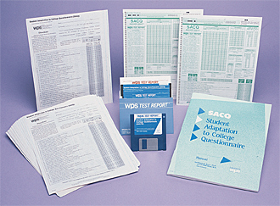

This quick, convenient instrument helps determine how well a student is handling the demands of college. SACQ assesses overall adjustment to college, as well as adjustment in four specific areas:
- Academic Adjustment
- Personal-Emotional Adjustment
- Social Adjustment
- Attachment (to the institution)

Used by many universities for routine freshman screening, SACQ is a cost-effective way to detect problems early in the student's college career. And because it indicates the nature of those problems, SACQ provides clear guidelines for subsequent intervention. It is particularly useful in identifying potential dropouts.
This 67-item, self-report questionnaire can be administered to individuals or groups in just 15 to 20 minutes. It can even be mailed to students, self-administered at home, and then returned for scoring. The convenient AutoScoreTM Test Form simplifies scoring and profiling results.
If you are testing large groups of students, you may prefer computer scoring and interpretation. You can use WPS TEST REPORT prepaid Mail-In Answer Sheets to get detailed interpretive reports. Norms are based on a sample of more than 1,300 male and female college freshmen and stratified by semester of attendance (first and second semesters in college). The SACQ Manual includes an extensive list of studies using the test.
The questionnaire helps overcome the reluctance of many students to seek help--90 percent of those with low SACQ scores accept offers of a posttest interview. The questionnaire gives you reason for follow-up, as well as specific topics for discussion and a clear path toward effective intervention.
By detecting adjustment problems early, SACQ can help colleges retain students who might otherwise drop out.

